1.Extracted Data
Target artifact | Technology | Year | Item | Feature Type | Feature Extraction | Model Training | Baseline | Measure
User review | DeepMatcher | 2021 | Error: Reference source not found | App feature | DistilBERT | Cosine similarity | - | Hit,MAP
Pull-request | ML models | 2023 | Error: Reference source not found | Text | TF-IDF | KMeans, BIRCH | - | V-measure
Revision | LCDTrace classifier | 2022 | Error: Reference source not found | Process-related, document, IR, query quality | TF-IDF | RF, GBDT | - | F-measure,Recall
Revision | LCDTrace tool | 2023 | Error: Reference source not found | Process-related, document, IR, query quality | MRMR | RF, GBDT | - | Precision,F-measure
Issue | Label Recovery | 2021 | [34] | Text, metadata | TF-TDF, FastText | LR, RF, Neural Network | ZeroR | F-measure
Issue | DL-based | 2022 | [37] | Text | TF-IDF | RF | TricketTagger | Precision,Recall,F-measure
Issue | Software Feature Request Detection | 2016 | [38] | Software feature(request feature) | Bag of Word | NB,MNB,SVM,LR,SGD,DT,RF | - | Precision,F-measure,Recall
Code | Learning-to-Rank | 2014 | [36] | Query dependent, Query independent | TF-IDF | Learning-to-Rank | BugLocator,VSM,Usual Suspects,BLUiR,BugScout | MAP,MRR
Code | HyLoc | 2015 | [32] | Text, relevancy, metadata | rVSM, DNN | DNN | NB,LR,BugLocator | MAP,MRR
Test case | Improvement techniques | 2020 | Error: Reference source not found | System feature | TF-IDF, Word2Vec | LSI, LDA, BM25, CNN | LSI, LDA, BM25, Word2Vector | Precision,F-measure,Recall
Test case | Use system features | 2021 | Error: Reference source not found | System feature | TF-IDF, Word2Vec | LSI, LDA, BM25, CNN | - | Precision,F-measure,Recall
Commit | RCLinker | 2015 | [33] | Text, metadata | TF-IDF | RF | MLINK | Precision,Recall,F-measure
Commit | PULink | 2017 | [35] | Text, metadata | TF-IDF | RF | FRLink | Precision,Recall,F-measure
Commit | FRLink | 2017 | [26] | Text, code | TF-IDF | Learning threshold | RCLinker | Precision,Recall,F-measure,MCC
Commit | RF classifier | 2018 | Error: Reference source not found | Text, code, process | VSM-nGram | RF | - | Precision,F-measure,Recall
Commit | KGDeepLink | 2019 | Error: Reference source not found | Text, code | Word2Vec | SVM | PULink | Precision,F-measure,Recall
Commit | DeepLink | 2019 | Error: Reference source not found | Text, code | Word2Vec | RNN | FRLink | Precision,F-measure,Recall
Commit | GVSM based method | 2020 | Error: Reference source not found | Text | Word2Vec | GVSM | VSM, LSI, LDA, GVSM | AP
Commit | T-BERT | 2021 | Error: Reference source not found | Text, code | CodeBERT | Neutral classifier | VSM, LDA, LSI, TNN-LSTM, TNN-BiGRU | Precision,F-measure,MAP,MRR
Commit | Hybrid-Linker | 2021 | Error: Reference source not found | Text, nontext, code | TF-IDF | GB, GB + XGBoost | DeepLink, FRlink | Precision,F-measure,Recall
Commit | MT-BERT | 2022 | Error: Reference source not found | Text | Multilingual BERT | Neutral classifier | VSM, LSI, LDA, GVSM | AP
Commit | SPLINT | 2022 | Error: Reference source not found | Text, code | TF-IDF | Semi-supervised Learning | VSM, Random forest | Precision,F-measure,Recall
Commit | BTLink | 2023 | Error: Reference source not found | Text, code | RoBERTa, CodeBERT | Fully connected layer | FRLink, DeepLink, hybrid-linker | Precision,F-measure,Recall,MCC,AUC,ACC,PF
Commit | EALink | 2023 | Error: Reference source not found | Text, code, nontext | RoBERTa, CodeBERT | Cosine similarity | VSM,T-BERT, DeepLink | Precision,Hit,MRR

2.Search process record
Database | Number of searches | Number of repetitions in each database | Number of each database (After deleting repetitions) | Number of repetitions in all databases | Total number  (After deleting repetitions)
ACM | 417 | 76 | 341 | 1182 | 271
Springer | 690 | 0 | 690 | 1182 | 368
Science Direct | 786 | 403 | 383 | 1182 | 297
EI | 25 | 0 | 25 | 1182 | 20
IEEE | 582 | 142 | 440 | 1182 | 156
Web of Science | 792 | 0 | 792 | 1182 | 375
Total | 3292 | 621 | 2671 | 1182 | 1487

Excute inclusion/exclusion criteria
Database | apply criteria  （ISC1-ISC3, ESC1-ESC3） | apply criteria(ISC1-ISC4, ESC1-ESC3) in title, abstract, keywords | apply criteria(ISC1-ISC4, ESC1-ESC3) in full article | Snowballing | final
ACM | 516 | 83 | 15 | 1 | 16
Springer
Science Direct
EI
IEEE
Web of Science

Search records
Digital Libraries：
Database | Website
ACM | https://dl.acm.org/
Springer | https://www.springer.com/
Science Direct | https://www.sciencedirect.com/
EI | https://www.engineeringvillage.com/
IEEE | https://ieeexplore.ieee.org/
Web of Science | https://www.webofscience.com/wos/
Search terms：
P1 | traceability recovery | I1 | issue
P2 | traceability maintenance | I2 | bug
P3 | traceability assessment
P4 | requirements traceability
P5 | requirements trace
P6 | requirements tracing
P7 | software traceability
P8 | software trace
P9 | software tracing
- ACM
 | Keywords+Title+Abstract
(I1 OR I2)  AND  (P1 OR P2 OR P3 OR P4 OR P5 OR P6 OR P7 OR P8 OR P9) | 249
Advanced search:
("issue" OR "bug") AND ("traceability recovery" OR "traceability maintenance" OR "traceability assessment" OR "requirements traceability" OR "requirements trace" OR "requirements tracing" OR "software traceability" OR "software trace" OR "software tracing")
Screenshot of search process in ACM:
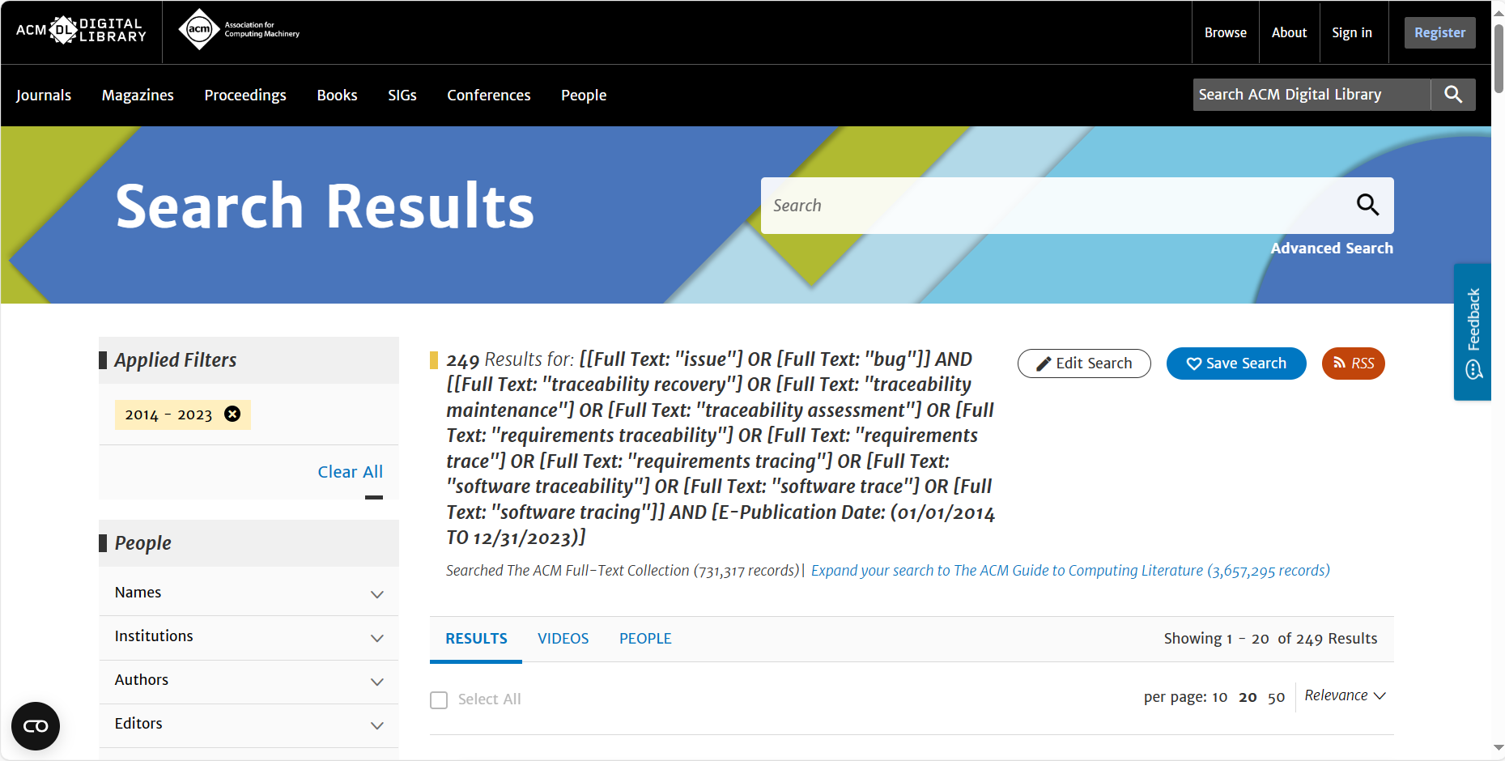
- Spinger
 | Keywords+Title+Abstract
(I1 OR I2)  AND  (P1 OR P2 OR P3 OR P4 OR P5 OR P6 OR P7 OR P8 OR P9) | 1019
Advanced search:
("issue" OR "bug") AND ("traceability recovery" OR "traceability maintenance" OR "traceability assessment" OR "requirements traceability" OR "requirements trace" OR "requirements tracing" OR "software traceability" OR "software trace" OR "software tracing")
Screenshot of search process in Springer:
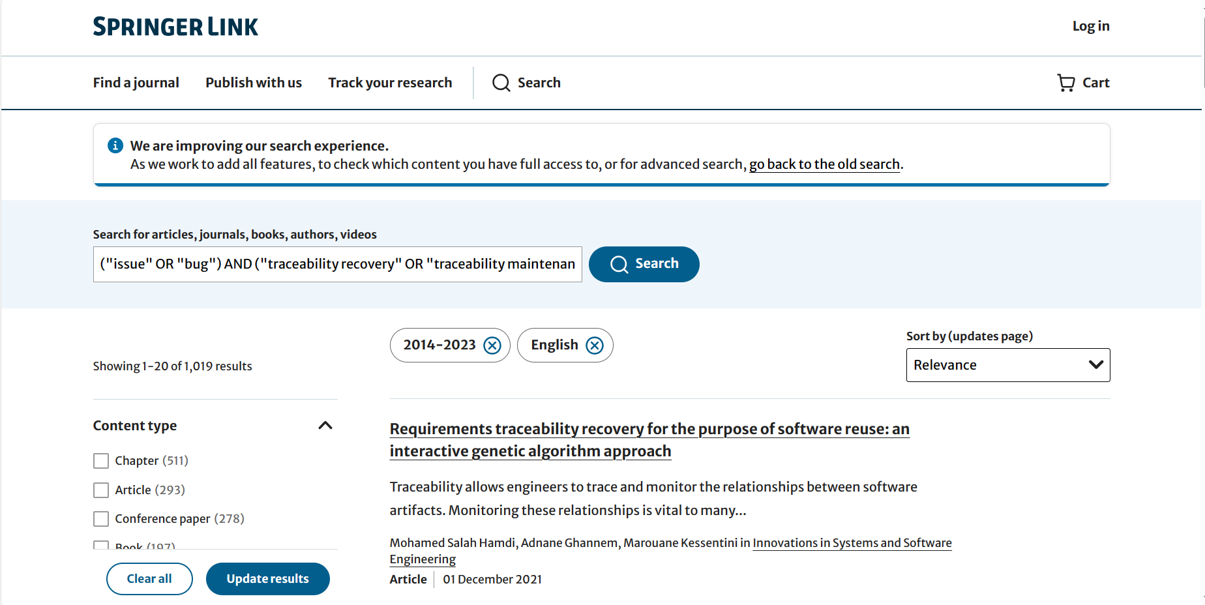
- Science Direct
 | Keywords+Title+Abstract
(I1 OR I2) AND (P1) | 119
(I1 OR I2) AND (P2) | 47
(I1 OR I2) AND (P3) | 312
(I1 OR I2) AND (P4) | 196
(I1 OR I2) AND (P5) | 196
(I1 OR I2) AND (P6) | 33
(I1 OR I2) AND (P7) | 109
(I1 OR I2) AND (P8) | 109
(I1 OR I2) AND (P9) | 34
- Advanced search((I1 OR I2) AND (P1)):
(issue OR bug) AND (traceability recovery)
Screenshot of search process in Scienct Direct:
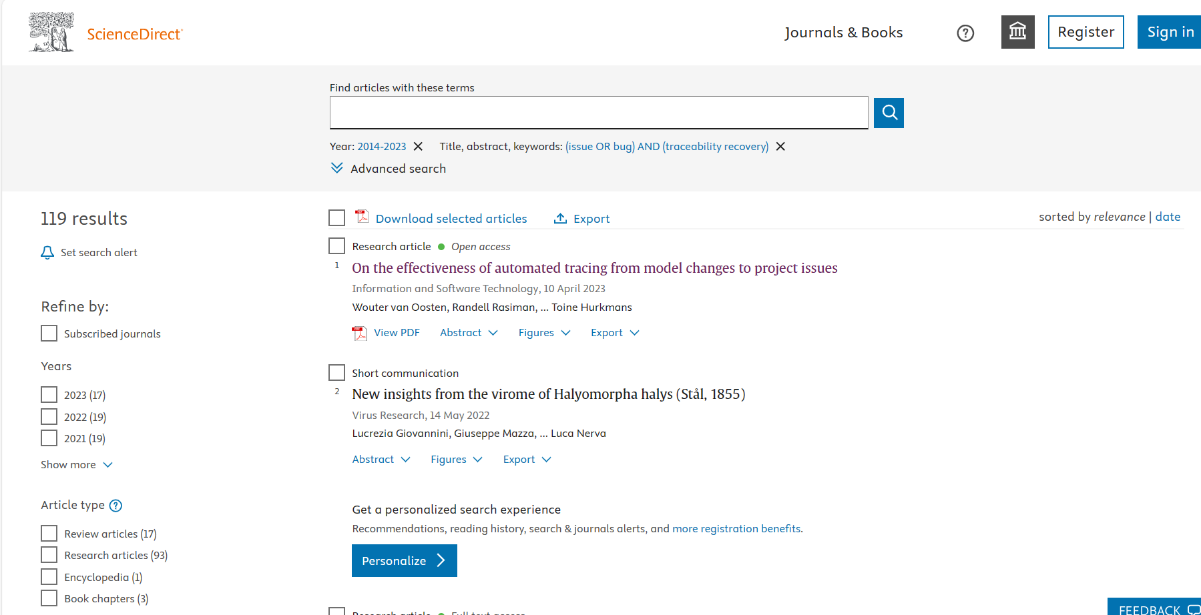
- Advanced search((I1 OR I2) AND (P2)):
(issue OR bug) AND (traceability maintenance)
Screenshot of search process in Scienct Direct:
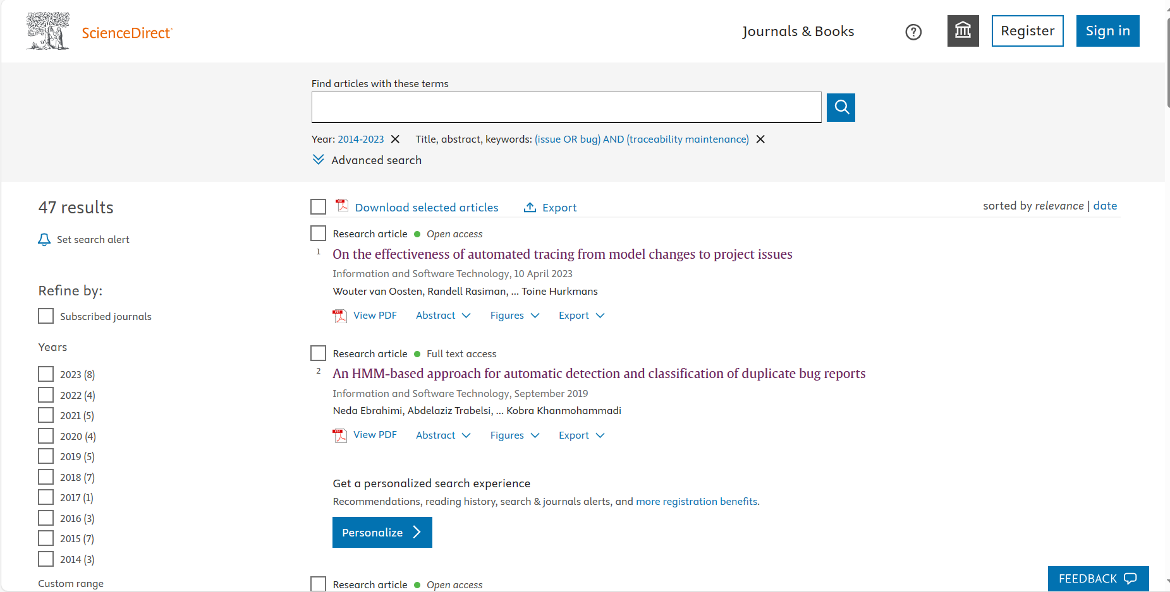
- Advanced search((I1 OR I2) AND (P3)):
(issue OR bug) AND (traceability assessment)
Screenshot of search process in Scienct Direct:
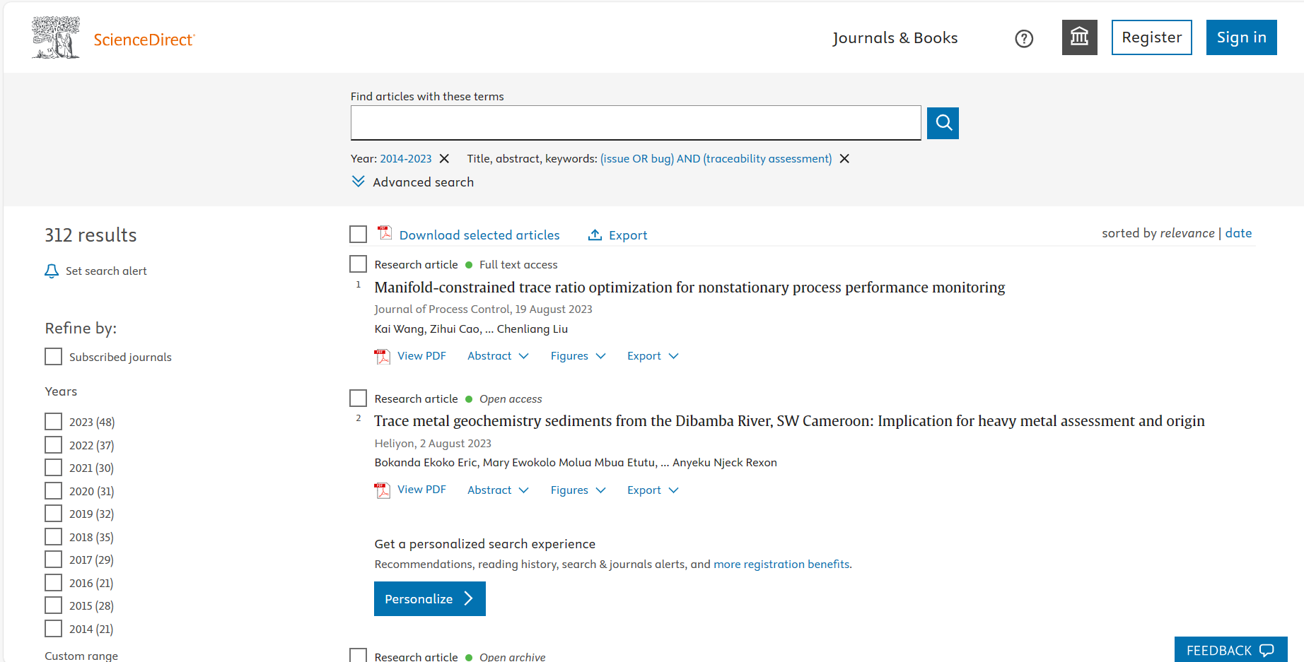
- Advanced search((I1 OR I2) AND (P4)):
(issue OR bug) AND (requirements traceability)
Screenshot of search process in Scienct Direct:
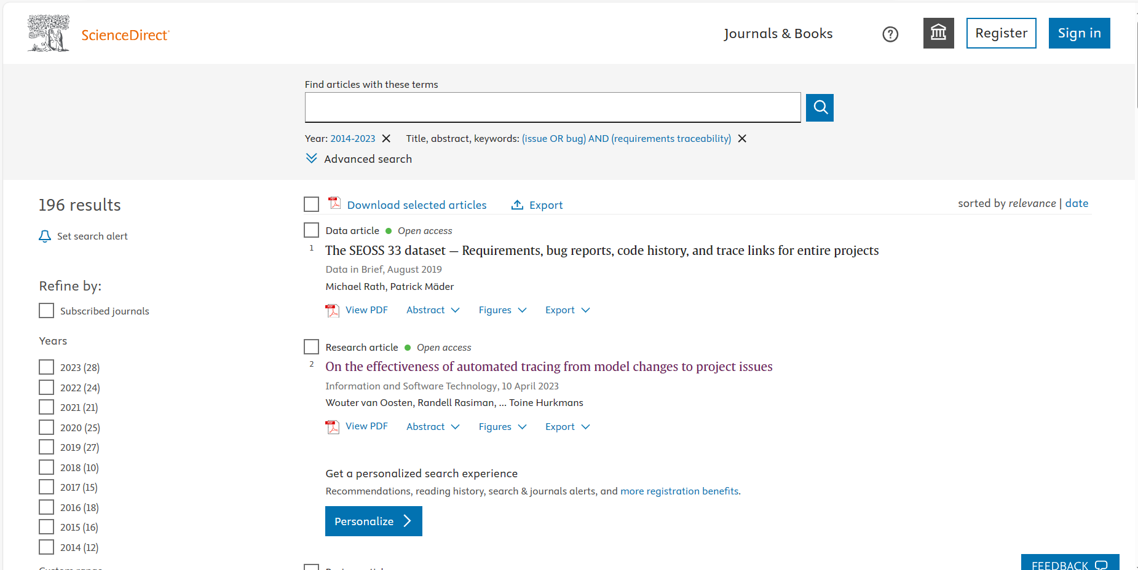
- Advanced search((I1 OR I2) AND (P5)):
(issue OR bug) AND (requirements trace)
Screenshot of search process in Scienct Direct:
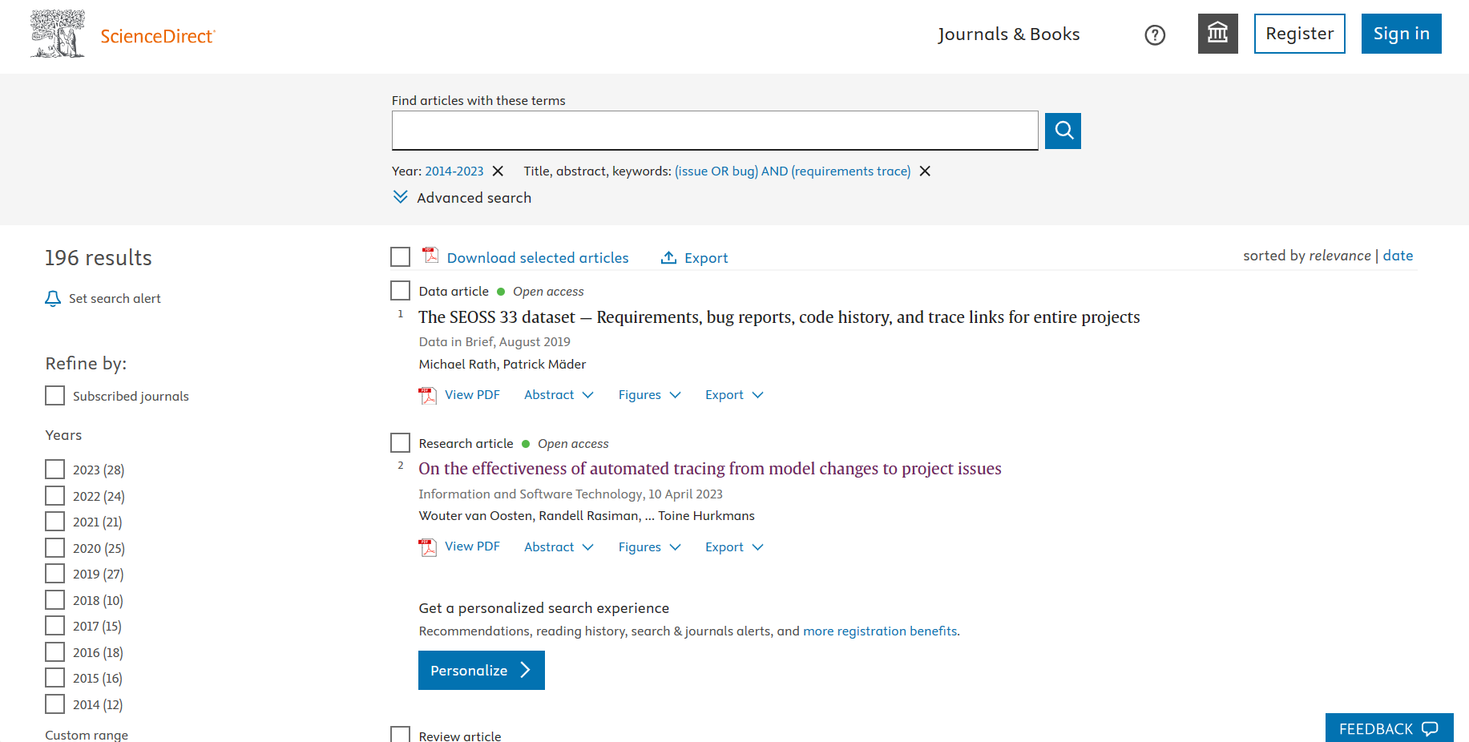
- Advanced search((I1 OR I2) AND (P6)):
(issue OR bug) AND (requirements tracing)
Screenshot of search process in Scienct Direct:
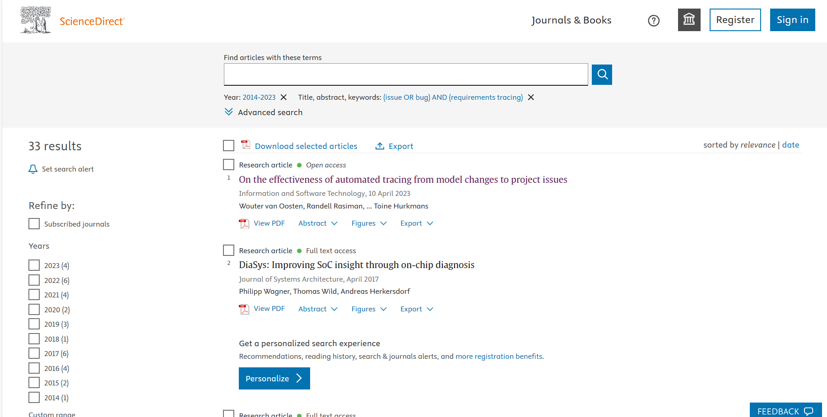
- Advanced search((I1 OR I2) AND (P7)):
(issue OR bug) AND (software traceability)
Screenshot of search process in Scienct Direct:
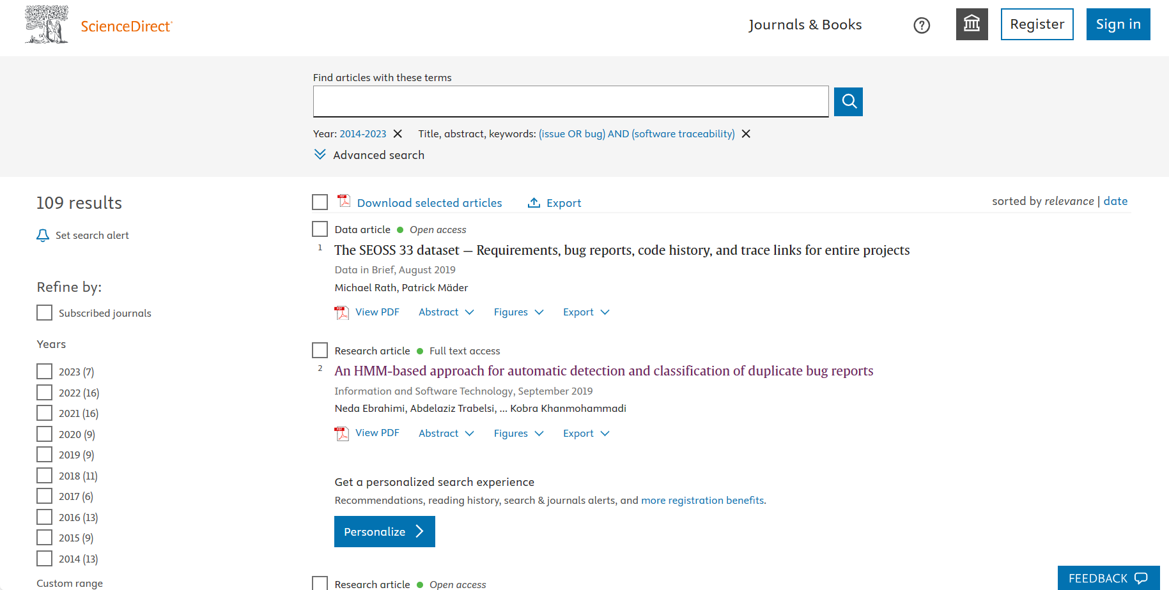
- Advanced search((I1 OR I2) AND (P8)):
(issue OR bug) AND (software trace)
Screenshot of search process in Scienct Direct:
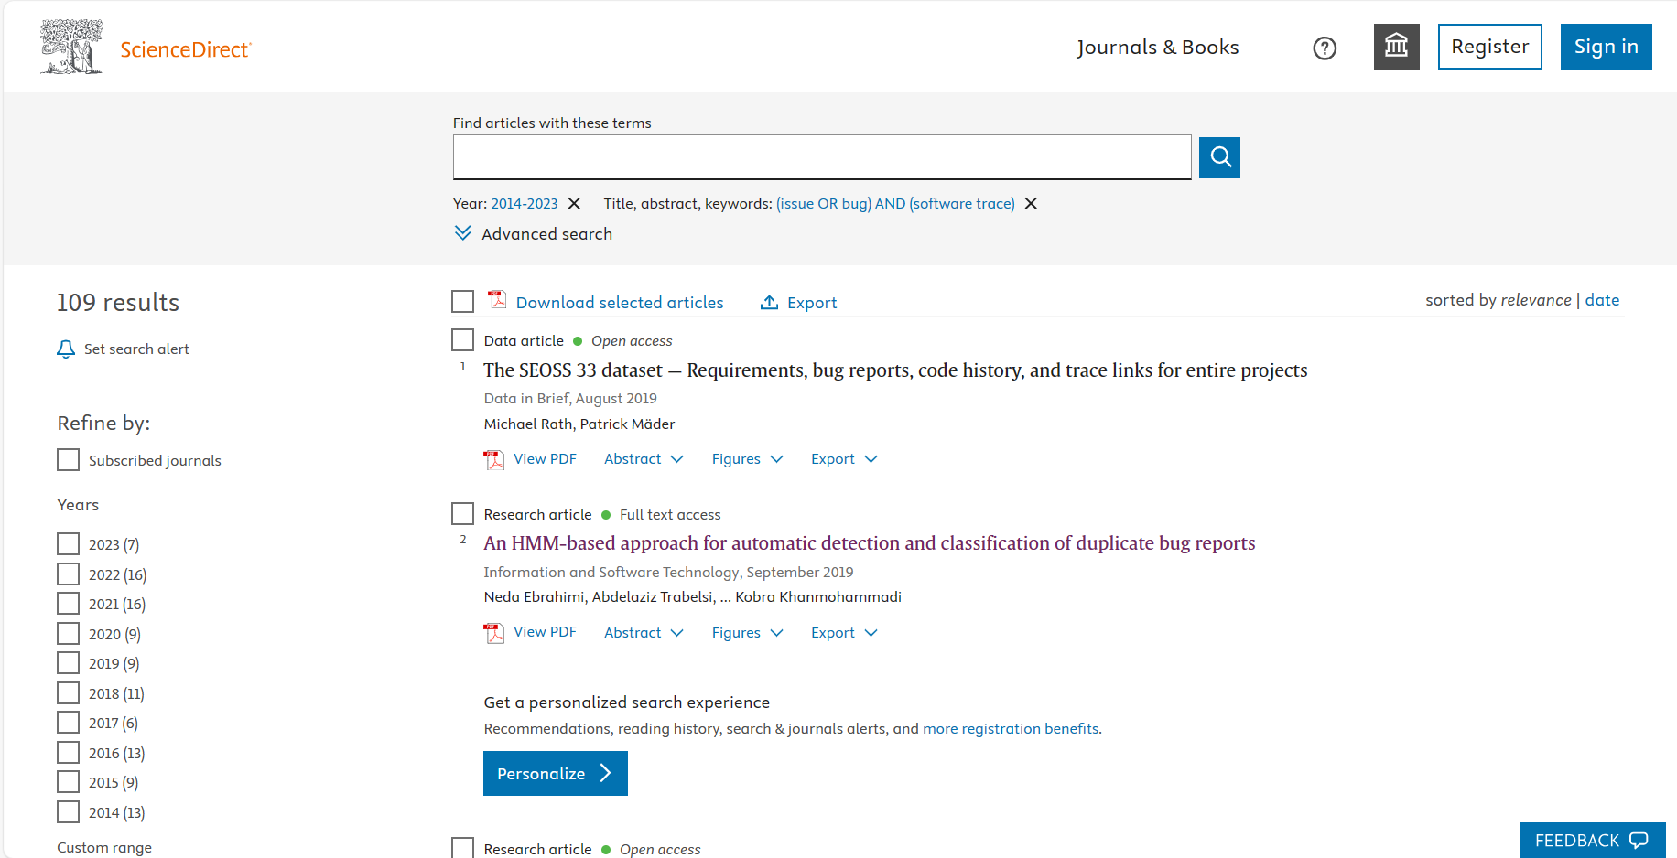
- Advanced search((I1 OR I2) AND (P9)):
(issue OR bug) AND (software tracing)
Screenshot of search process in Scienct Direct:
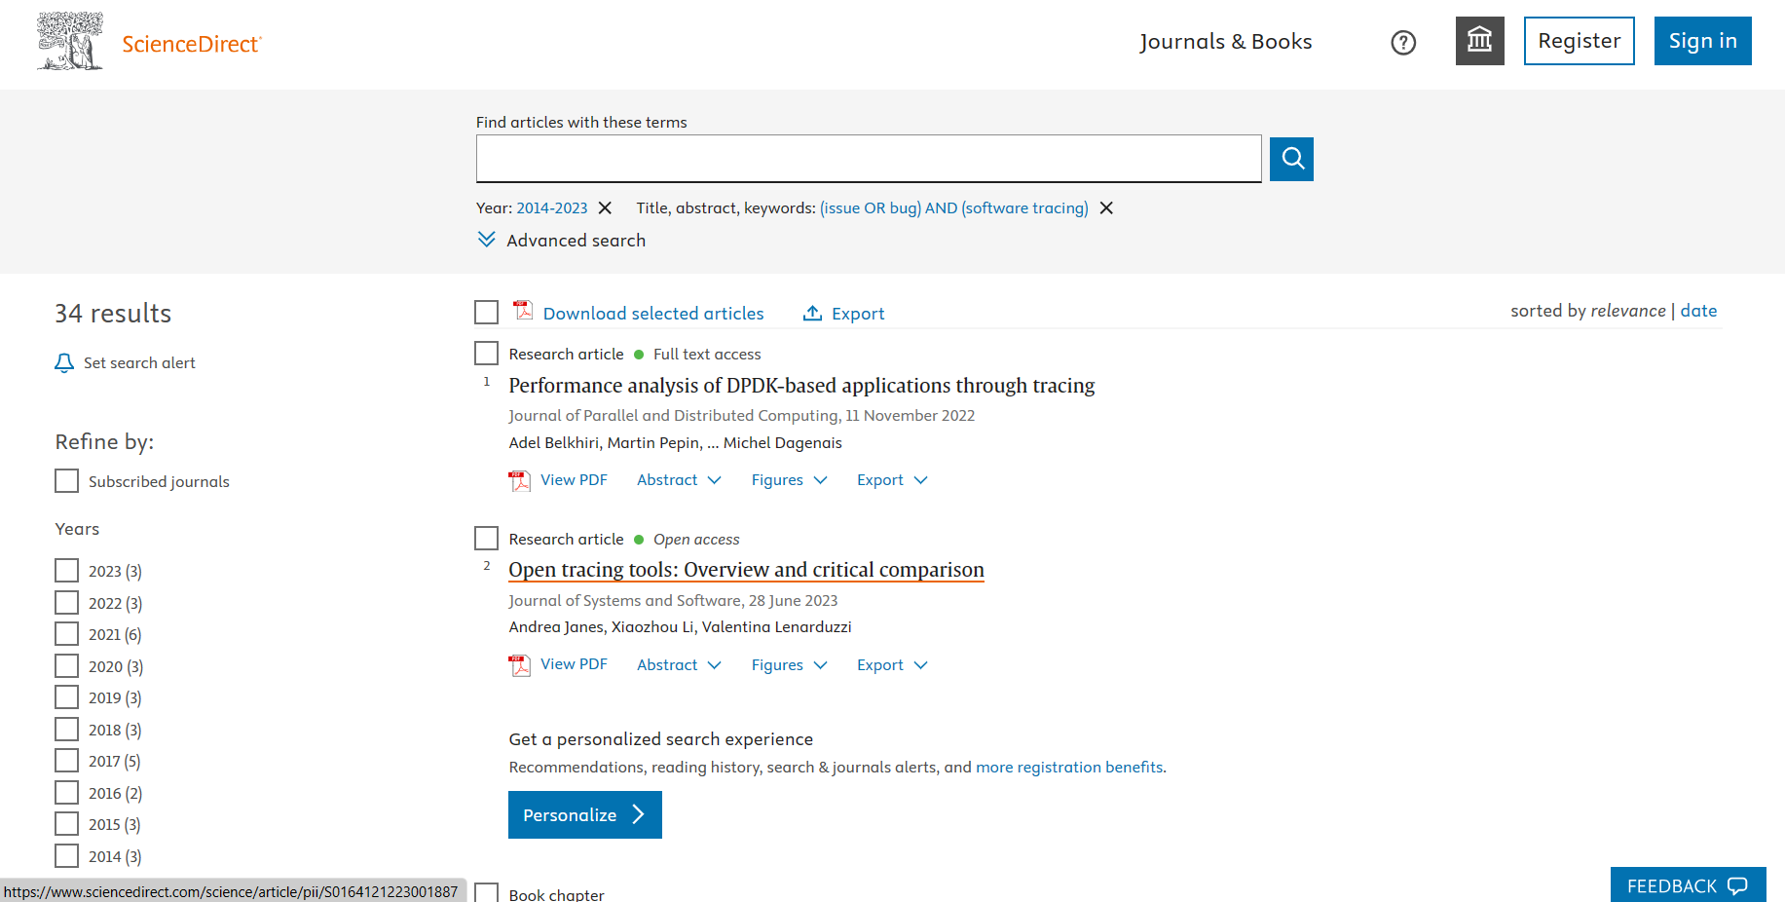
- EI
 | Subject/Title/Abstract
(I1 OR I2)  AND  (P1 OR P2 OR P3 OR P4 OR P5 OR P6 OR P7 OR P8 OR P9) | 70
Expert search:
("issue" OR "bug") AND ("traceability recovery" OR "traceability maintenance" OR "traceability assessment" OR "requirements traceability" OR "requirements trace" OR "requirements tracing" OR "software traceability" OR "software trace" OR "software tracing")
Screenshot of search process in EI:
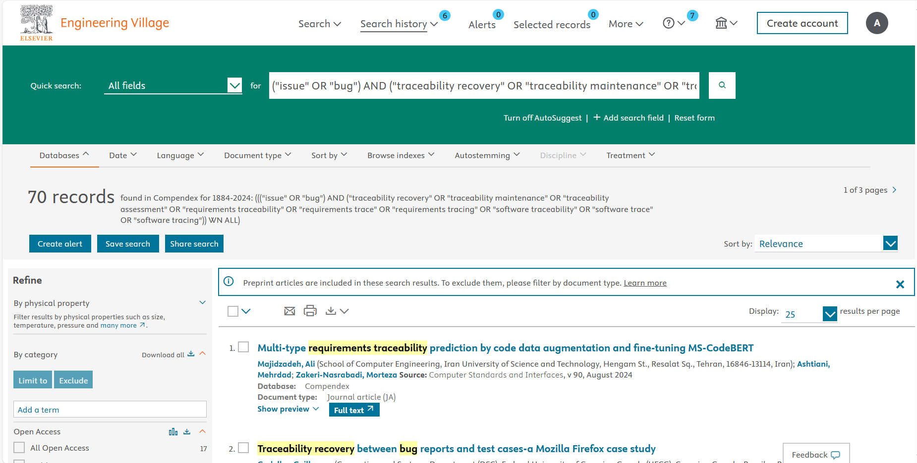
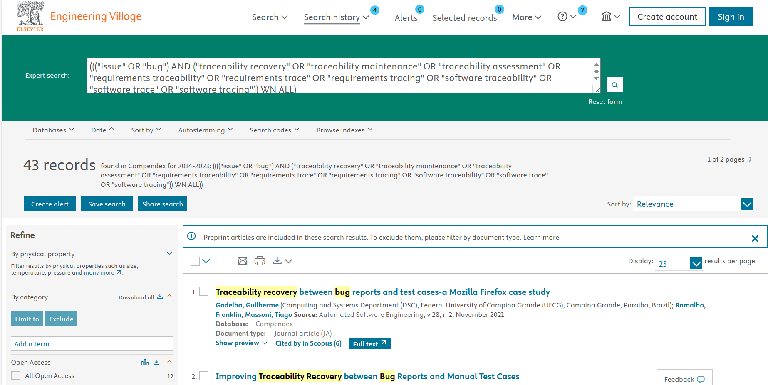
- IEEE
 | Title | Abstract | Index terms
(I1 OR I2) AND (P1 OR P2 OR P3 OR P4 OR P5 OR P6 OR P7 OR P8 OR P9 OR P10) | 5 | 135 | 248
Total | 388
- Command Search(Title):
("Document Title":issue OR "Document Title":bug) AND ("Document Title":traceability recovery OR "Document Title":traceability maintenance OR "Document Title":traceability assessment OR "Document Title":requirements traceability OR "Document Title":requirements trace OR "Document Title":requirements tracing OR "Document Title":software traceability OR "Document Title":software trace OR "Document Title":software tracing)
Screenshot of search process in IEEE:
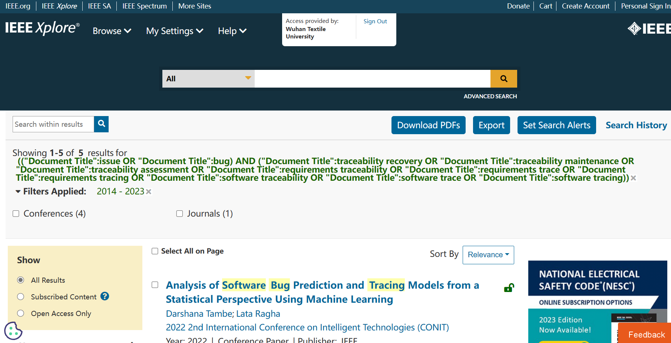
- Command Search(Abstract):
("Abstract":issue OR "Abstract":bug) AND ("Abstract":traceability recovery OR "Abstract":traceability maintenance OR "Abstract":traceability assessment OR "Abstract":requirements traceability OR "Abstract":requirements trace OR "Abstract":requirements tracing OR "Abstract":software traceability OR "Abstract":software trace OR "Abstract":software tracing)
Screenshot of search process in IEEE:
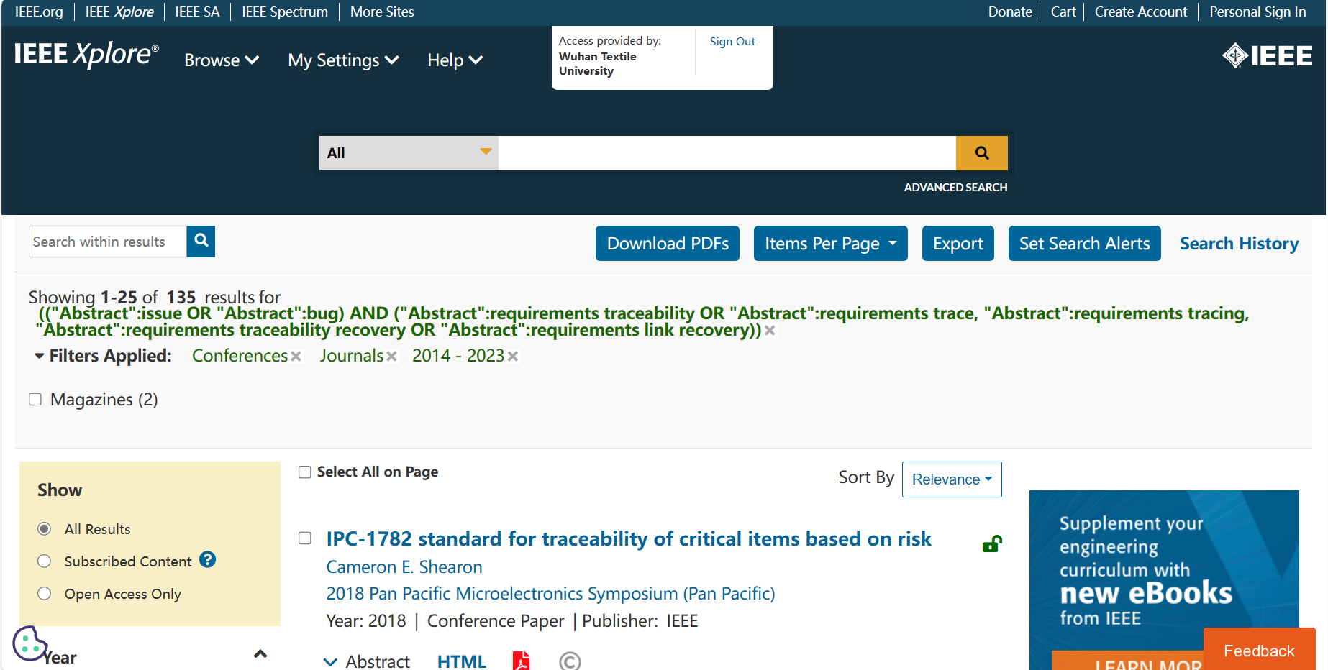
- Command Search(Index Terms):
("Index Terms":issue OR "Index Terms":bug) AND ("Index Terms":traceability recovery OR "Index Terms":traceability maintenance OR "Index Terms":traceability assessment OR "Index Terms":requirements traceability OR "Index Terms":requirements trace OR "Index Terms":requirements tracing OR "Index Terms":software traceability OR "Index Terms":software trace OR "Index Terms":software tracing)
Screenshot of search process in IEEE:
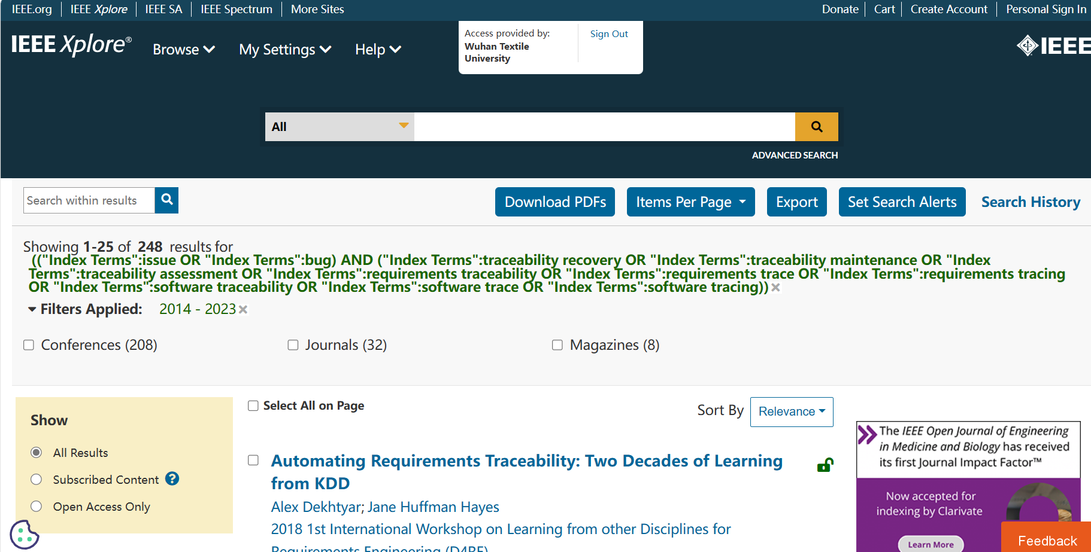
- Web of Science
 | Topic(Searches title, abstract, author keywords, and Keywords Plus.)
(I1 OR I2) AND (P1 OR P2 OR P3 OR P4 OR P5 OR P6 OR P7 OR P8 OR P9 OR P10) | 1073

Advanced Search(Topic):
(issue OR bug) AND (traceability recovery OR traceability maintenance OR traceability assessment OR requirements traceability OR requirements trace OR requirements tracing OR software traceability OR software trace OR software tracing)
Screenshot of search process in IEEE:
